[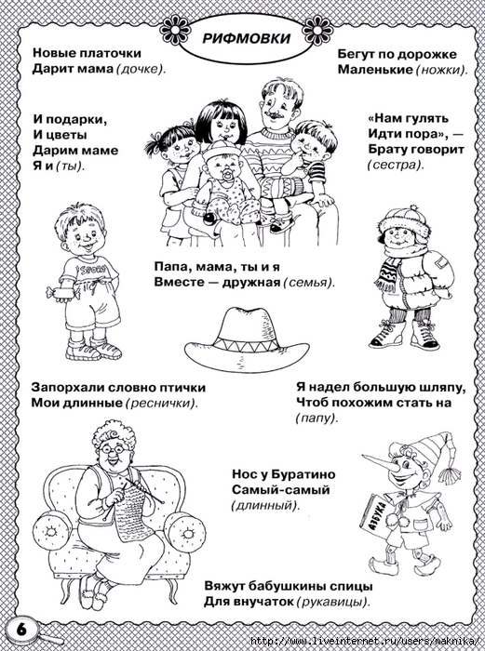](https://img1.liveinternet.ru/images/attach/c/8/101/338/101338033_large_y7.jpg)  
  
  
[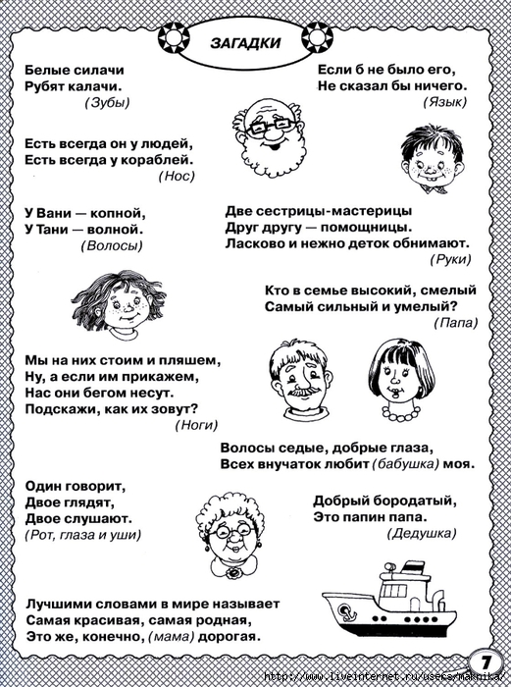](https://img0.liveinternet.ru/images/attach/c/8/101/338/101338034_large_y8.jpg)  
  
  
[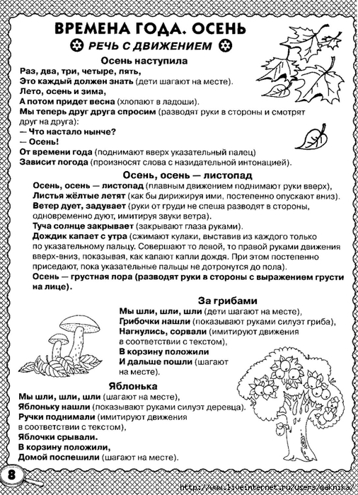](https://img1.liveinternet.ru/images/attach/c/8/101/338/101338035_large_y9.jpg)  
  
  
[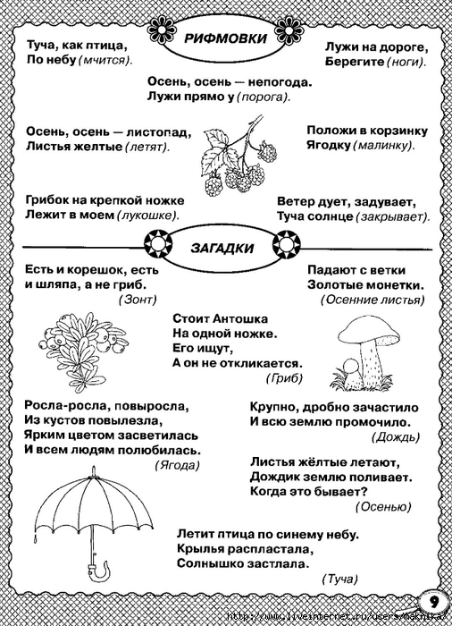](https://img0.liveinternet.ru/images/attach/c/8/101/338/101338036_large_y10.jpg)  
  
  
[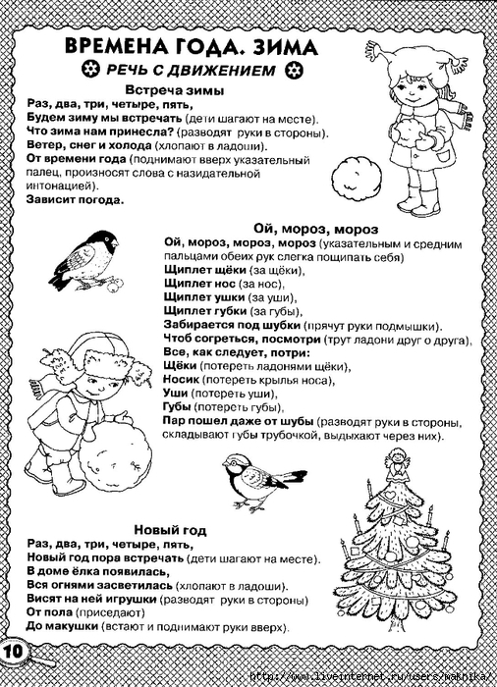](https://img1.liveinternet.ru/images/attach/c/8/101/338/101338037_large_y11.jpg)  
  
[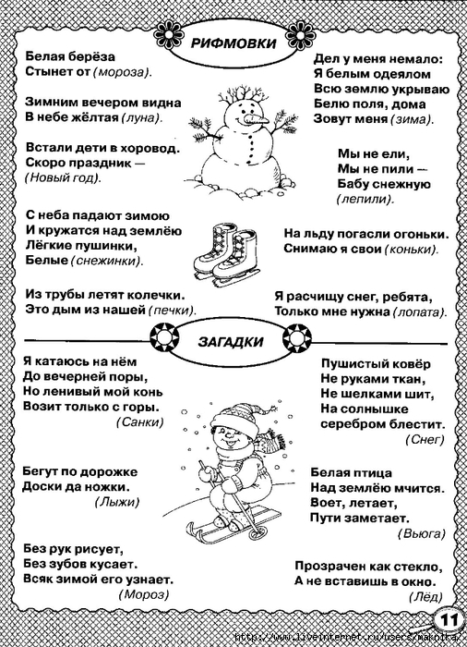](https://img0.liveinternet.ru/images/attach/c/8/101/338/101338038_large_y12.jpg)  
  
  
[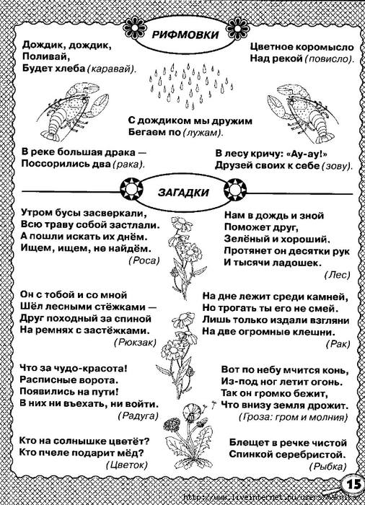](https://img1.liveinternet.ru/images/attach/c/8/101/338/101338043_large_y16.jpg)  
  
[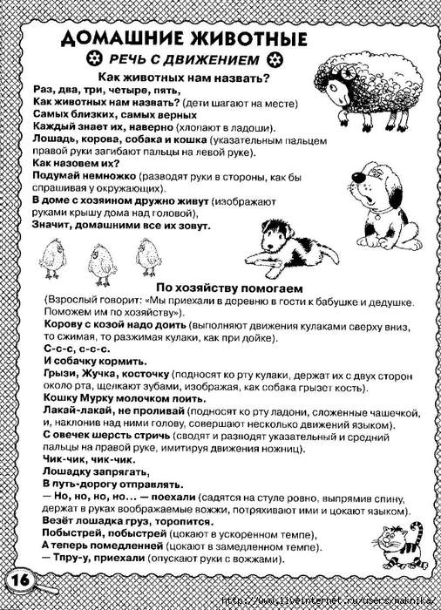](https://img0.liveinternet.ru/images/attach/c/8/101/338/101338044_large_y17.jpg)